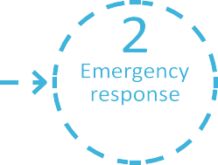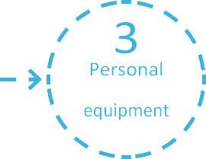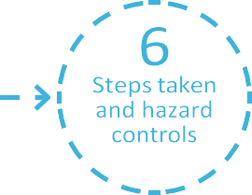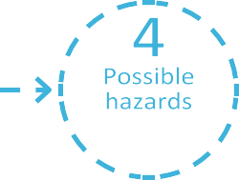

Please fill in all sections

Sign on and submit form

project

protective

and updates to the JSA

information

(PPE)

1. Site and project details

Site name

Project name/work order #

Post

Code

Site address: Number

Street name

Suburb

Work location/process area:

Authorised access (AA) #:

Service provider undertaking the works:

JSA #:

JSA developed by:

(*Person in charge of work)*

Work planned start date:

Work planned end date

Description of the works *(Scope of work*)

Reviewed by *(Watercare representative)*

Confirmation to proceed with work *(Watercare*

Name

Name

*approver)*

Date and signature

Date and Signature

**continued >>>**

HSW-010-FOR-006.1 V6

AUGUST 2024

Website: [www.watercare.co.nz](http://www.watercare.co.nz/)





Job safety analysis (JSA)

2

2. Emergency response information

Contact phone

Contact phone

Contact phone

Contact phone

Control room: water/wastewater treatment plant:

Contact phone

Nerve Center New Market: full name

Contact phone

Nearest medical facility address and contact details:

Evacuation point

First Aid kit location

3. Personal protective equipment - mark all that apply

High visibility clothing

Protective clothing

Breathing apparatus

Foot protection

Dust mask

Respirator

Head protection

Life vest

Eye protection

Safety harness

Hearing protection

Face shield

Hand protection

Welding mask

Gas detection

Portable radio

Fire extinguisher

Tripod and winch

First Aid kit

Portable ventilation

Emergency contacts

HSW-010-FOR-006.1 V6 AUGUST 2024

IMPORTANT: Injuries, incidents and near misses must be reported to your Watercare representative without delay. For

IN THE EVENT OF AN EMERGENCY DIAL 111 serious events, the incident scene must not be altered (unless to make it safe) and all work in the vicinity of the event must

cease until permission to proceed has been granted by your Watercare representative.





Job safety analysis (JSA)

4. Hazards - what could cause harm? Mark all that apply

3

**continued >>>**

HSW-010-FOR-006.1 V6

AUGUST 2024

Stacking/racking Suspended loads Lifting equipment

Loading/unloading

Fixed plant and equipment

Mobile plant and equipment

Fatigue Impairment Working alone

Road corridor traffic

Site traffic

Pedestrians

Other:

Public/Third parties Animals

Hot works

Flammable substances Explosive gases

Chemicals (liquid/gas/fume) Hazardous Materials

Asbestos

Chemical or environmental dust

Water bodies

Dams, lakes, ponds, lagoons

Channels/aqueducts

Pipelines Reservoirs/wells

Hazardous surface conditions Hot/cold temperature

Poor visibility Unstable ground Noise

Vibration Weather

Sharps, needles and broken items

Explosive Atmosphere Zone

*Electrical equipment for hazardous area (EEHA)*

Major Hazard Facility (MHF)

Heavy Lifting

Repetitive

Other:

Structure without barrier Ladder

Skylight or non-weight

bearing structure

Other:

Facility entry point (covers and manholes etc)

Confined space

Toxic Gas (H2S, Methane etc)

Viral / bacterial Rodents / insects

Trench / excavation

Penetration Tunnelling

Mechanical

Electrical

Hydraulic / Pneumatic Ultraviolet (UV) Gravitational/Potential

Underground/Overhead Services

Other:



Job safety analysis (JSA)

4

5. Workpack documentation - tick all that apply, attach PDFs or jpgs or physical copies to this form

Work methodology/SOP

Electricity - what voltage?

Worksafe notification form

Pressure/fluid/air - what product?

CAR form (change form)

Gas - what pressure?

Site plans/drawings

Water/sewer/storm water - mains?

Lift plan

Communication/phone - what type?

MHF regulation applies

CSRP (Change to system risk profile)

Electrical equipment for hazardous

area regulation applies

Other (explain):

Isolation Request

Self-isolation (LOTO)

**continued >>>**

HSW-010-FOR-006.1 V6

AUGUST 2024

Isolations required: Y/N

Record energy isolation/safety arrangements agreed with Watercare Operations or utility provider:

Hazardous energy permit

Hot work permit

Safety device impairment permit

Work at height permit

Explosive atmosphere area permit

High risk activity permit

Excavation permit

Confined space Permit

Permits to work *attachments*

Interaction with utilities: Y/N

Supporting documentation: Y/N

Regulator notification: Yes: No:



Job safety analysis (JSA)

5

**Permit to Work – Decision Trees**

Use the Permit to Work Decision Tree to assess activity

risks and determine if a permit is necessary. If the "YES" column is marked in the PTW column, a Permit to Work is mandatory. For entries marked with Y/N, the Permit Receiver and Permit Issuer should discuss necessary controls to decide on permit requirements. – *obtain PTW forms from your Watercare Representative.*

HSW-010-FOR-006.1 V6

AUGUST 2024

**Explosive Atmosphere Areas**

These are areas that encompass explosive atmosphere zones,

refer: *AS/NZS 60079.10.1:2009 Classification of areas –*

*Explosive atmospheres*

PTW

Req?

Is any of the work in a designated **explosive atmosphere zone**?

YES

Is any of the work undertaken in a designated **hazardous (explosive) area**, that is covered by an approved SOP?

Y/N

**Hot Work**

Where a source of ignition is introduced to a work environment

PTW

Req?

Does it involve any non-intrinsically safe activity or non- Ex rated equipment within a confined space where flammable or explosive conditions realistically could exist (be introduced through the work or normal conditions, or has been known to exist before in the space)?

YES

Does it involve any non-intrinsically safe activity or non- Ex rated equipment, within a designated explosive atmosphere zone?

YES

Will there be any hot work on equipment or pipes?

YES

Will there be any hot work in an operational plant, offices or admin areas?

Y/N

Will the hot work be undertaken outdoors, when a fire ban is in place and/or within 3 metres of a structure?

Y/N

**Working at Heights**

Working in place where a person could be injured if they fell from one level to another.

PTW

Req?

Will it involve working at a height of 5 metres or higher? (Notification to Worksafe?)

YES

Will it involve working at a height between 2 metres and 5 metres? **Excludes:** Under 5 metres when working from a scaffold erected by a competent person or from a scissor lift, a boom lift or a permanent ladder where the fall protection is permanently I equipment.

YES

Working at height less than 2m (NOTE: ALL height work must have safety controls planned and used)

NO

**Excavation**

Work involving the removal of soil or rock from

a site to form an open face trench, hole or cavity.

PTW

Req?

Will the excavation be deeper than 1.5metres?

YES

Is there a risk of atmospheric contamination or build-up of gases or fumes within the excavation?

YES

Is de-watering required?

YES

Will the excavation contain contaminated soil?

YES

**Safety Device Impairment**

Where the work will disable or affect emergency systems (emergency monitoring systems, fire fighting, escape or rescue systems) or safety critical elements on a Major Hazard Facility.

PTW

Req?

Will the work disable or affect emergency systems, including leaving a site operating with a disabled emergency alert system or safety device?

YES

Will the work disable or affect a MHF safety critical element as specified in the site MHF Safety Case (applies to Ardmore WTP only)

YES

**Confined Space**

Work in an enclosed or partially enclose space. **Note:**

The Watercare Confined Space Entry Certificate and

Confined Space Risk Decision Tree must be completed for ALL

Confined Space entries.

PTW

Req?

Is the residual risk score 2 or above on the Confined Space Decision Tree?

YES

Is the residual risk score 1 on the confined space decision tree?

NO

**Other High-risk Work**

Any other tasks where the risk assessment generates a controlled risk score in the red zone of the job safety analysis (JSA).

PTW

Req?

After planning safety measures to reduce risks, is the

level of risk remaining still considered high (4) or very high (5)?

Yes

Other high-risk activities not covered by a specfic permit,

i.e complex crane lifts, diving etc.

YES

**Hazardous Energy Permit**

Containing mechanical, chemical, electrical, thermal gravitational, potential, pneumatic or hydraulic

energy. **Note:** The Watercare Isolation Procedure & Isolation Certificate still applies.

**Note:** Work Type Competency (WTC) must be held if working on

or near Electrical Energy Areas

PTW

Req?

i.e. Motor Control Centre (MCC), Switch Rooms, Transformers, Earthing and Ring Main Unit (RMU)

Will it work involve working on High Voltage equipment?

YES

Will it involve live product work including all work either inside or on live wastewater or water pipes where either product or vapours may still be present?

YES

Will it involve working in a HV room or within 2 metres of HV equipment? (Excludes routine activities undertaken by WTC trained personnel, with a Watercare approved SOP).

YES

Will it involve working on live equipment, electrical circuits, energised pipes or pressure vehicles?

YES

Does the work require any remote isolation(s)?

YES

Does the work require energising during testing or commissioning?

YES

All other isolation of hazardous energy; the Watercare Isolation Procedure applies

NO





**CONFINED SPACE IDENTIFICATION CHART**

The identification of a confined space shall be done in accordance with the following process:

Is the Space intended or designed primarily for human

The Space may present a realistic risk from unsafe

YES

No

YES

Is the Space enclosed or partially enclosed?

occupancy?

levels of oxygen?

NO

YES

NO

YES

The Space may present a realistic risk from harmful airborne contaminants?

NO

The Space may present a realistic risk from stored free flowing solids or a rising level of liquid that may cause engulfment?

YES

NO

The Space may present a realistic risk of an airborne

contaminant that may cause a fire or explosion?

NO

YES

Effective 10 January 2015

Page **1** of **2**

Version 3.1

H&S Key Requirement - Confined space

**HSW-010-INS-006.4**

CONFINED SPACE

NOT A CONFINED SPACE

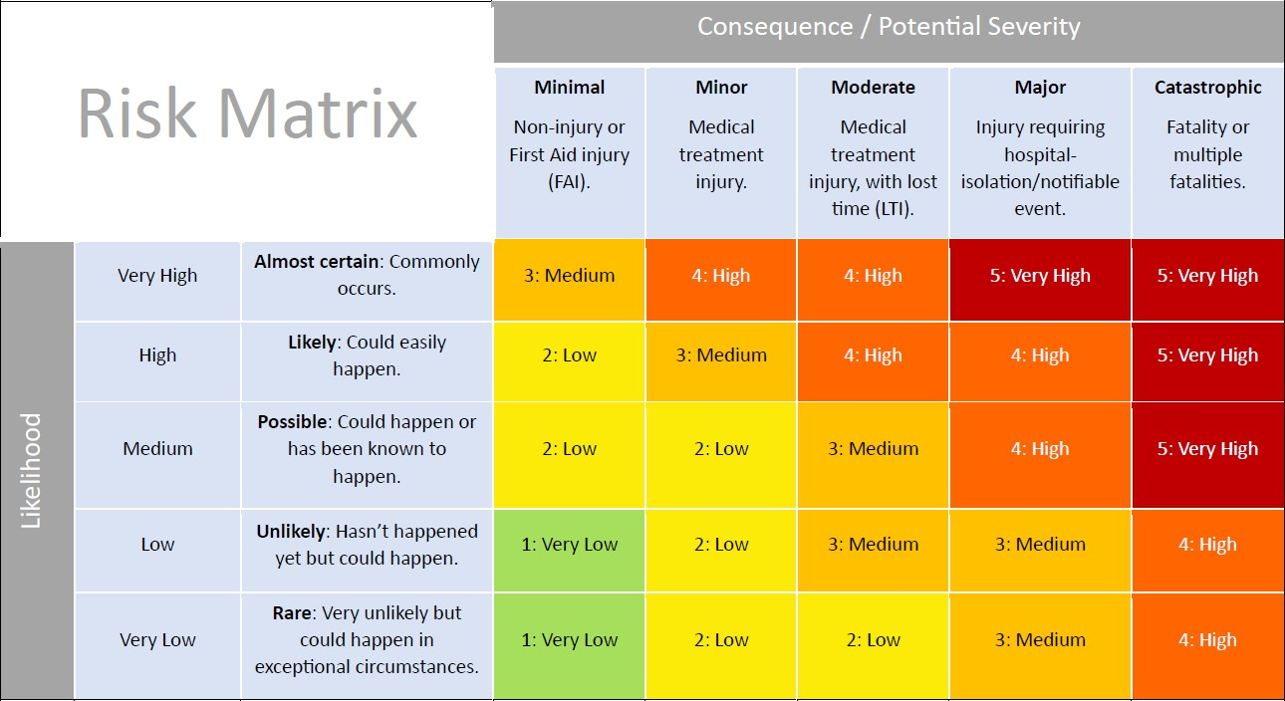

Job safety analysis (JSA)

6

6. Steps taken to complete the job

**continued >>>**

HSW-010-FOR-006.1 V6

AUGUST 2024

Hazards *(one per line)*

Hazard controls – what do we need to do to make it safe?

**What are we doing?**

*(step by step)*

**What could cause harm?**

**Existing risk level** (*use risk matrix)*

**Can we eliminate** If elimination is not possible, can we: If any risk stillremains:

**the risk?** - **substitute** and/or - use **admin controls** and/or **PPE** *(PPE is*

- **isolate** and/or *the least effective and should not be first*

*List how below* - use**engineering controls** *or the only control measure)*

Residual risk level

Job safety analysis (JSA)

7

**continued >>>**

HSW-F010-OR-006.1 V6

AUGUST 2024

**What are we doing?**

*(step by step)*

**What could cause harm?**

**Existing risk level** (*use risk matrix)*

**Can we eliminate** If elimination is not possible, can we: If any risk stillremains:

**the risk?** - **substitute** and/or - use **admin controls** and/or **PPE** *(PPE is*

- **isolate** and/or *the least effective and should not be first*

*List how below* - use**engineering controls** *or the only control measure)*

Residual risk level

**Hold point:** Authorisation to start any work must be obtained from a Watercare representative or control room prior to starting the work

Job safety analysis (JSA)

8

7. Site Map, Emergency Response Plan and diagrams

**Emergency Response Plan –** *include self-rescue, assisted rescue and emergency services rescue*

**Site Map/ diagrams/ isolations sketches**

**continued >>>**

HSW-010-FOR-006.1 V6

AUGUST 2024

Job safety analysis (JSA)

9

8. Changes and updates to the JSA

**continued >>>**

HSW-010-FOR-006.1 V6

AUGUST 2024

New hazards

*(one per line)*

Hazard controls – what do we need to do to make it safe?

**List any changes or modifications What could cause harm? to the job below, inorder**

**Existing risk level** (*use risk matrix)*

**Can we eliminate** If elimination is not possible, can we: If any risk stillremains:

**the risk?** - **substitute** and/or - use **admin controls** and/or **PPE** *(PPE is*

- **isolate** and/or *the least effective and should not be first*

*List how below* - use**engineering controls** *or the only control measure)*

Residual risk level

**Hold point:** All changes and modifications to the job must be authorised by a Watercare representative or control room











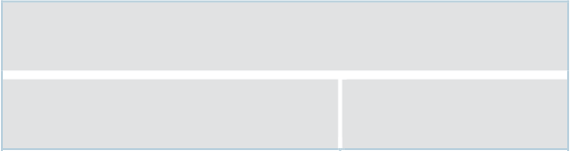

Job safety analysis (JSA)

JSA sign on: I have read and understood this JSA and agree to follow the plan, use the agreed hazard controls and work safely.

10

Sign on

Update Sign on

Date

Name

Signature

Position

Date

Time

Time

HSW-010-FOR-006.1 V6

AUGUST 2024

DD/ MM /YYYY

HH:MM

DD/ MM /YYYY

HH:MM

DD/ MM /YYYY

HH:MM

DD/ MM /YYYY

HH:MM

DD/ MM /YYYY

HH:MM

DD/ MM /YYYY

HH:MM

DD/ MM /YYYY

HH:MM

DD/ MM /YYYY

HH:MM

DD/ MM /YYYY

HH:MM

DD/ MM /YYYY

HH:MM

DD/ MM /YYYY

HH:MM

DD/ MM /YYYY

HH:MM

DD/ MM /YYYY

HH:MM

DD/ MM /YYYY

HH:MM

DD/ MM /YYYY

HH:MM

DD/ MM /YYYY

HH:MM

DD/ MM /YYYY

HH:MM

DD/ MM /YYYY

HH:MM

DD/ MM /YYYY

HH:MM

DD/ MM /YYYY

HH:MM

DD/ MM /YYYY

HH:MM

DD/ MM /YYYY

HH:MM

DD/ MM /YYYY

HH:MM

DD/ MM /YYYY

HH:MM

DD/ MM /YYYY

HH:MM

DD/ MM /YYYY

HH:MM

DD/ MM /YYYY

HH:MM

DD/ MM /YYYY

HH:MM

DD/ MM /YYYY

HH:MM

DD/ MM /YYYY

HH:MM

DD/ MM /YYYY

HH:MM

DD/ MM /YYYY

HH:MM

DD/ MM /YYYY

HH:MM

DD/ MM /YYYY

HH:MM